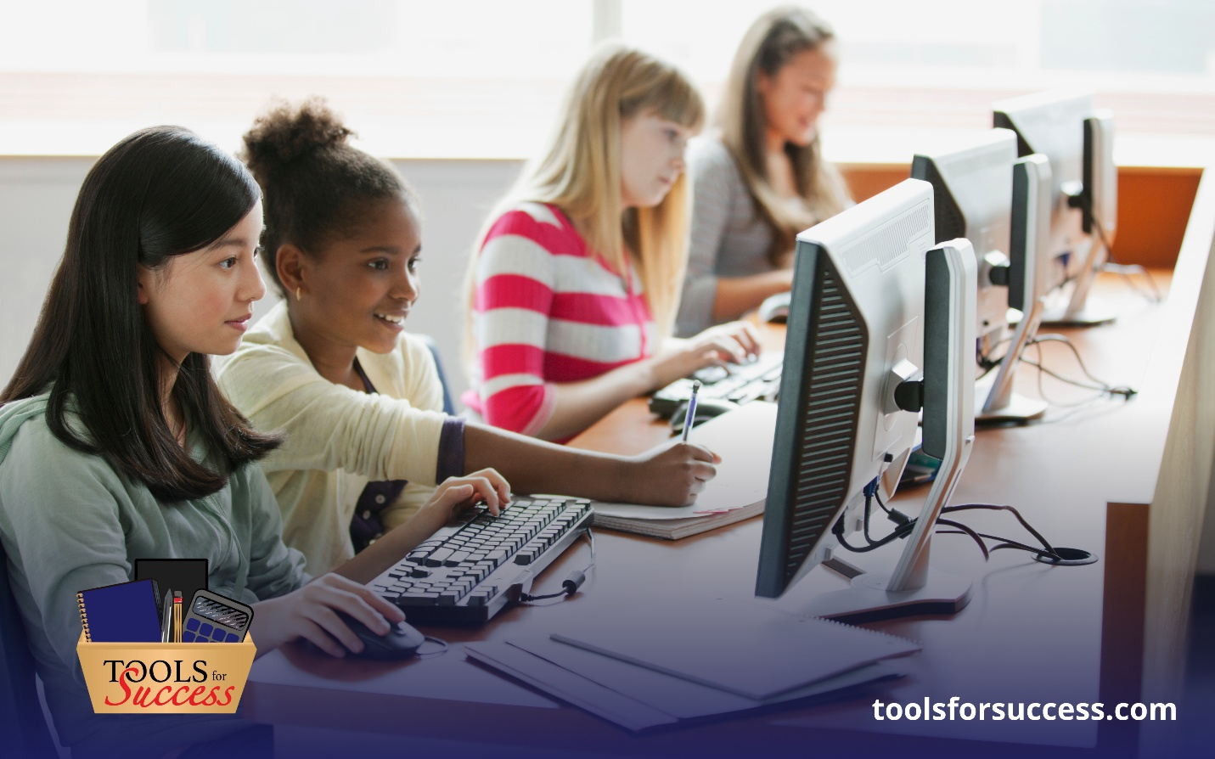

Practical Strategies for K-12 Educators to Reignite Motivation and Momentum in the New Semester
Momentum can fade as the school year progresses, but it doesn’t have to stay that way. With the right mindset and tools, educators can turn the new semester into a time of renewed energy, deeper connections, and increased classroom engagement. This is especially important as teachers balance instructional demands with the human work of teaching and learning.
The latest blog from Tools for Success offers actionable, teacher-tested strategies designed to help educators reignite their motivation and build momentum that sticks — all while prioritizing relationships, structure, and purpose. (toolsforsuccessindy.com
👉 Read the full article for steps educators can take now to bring clarity, confidence, and energy back into their classrooms.

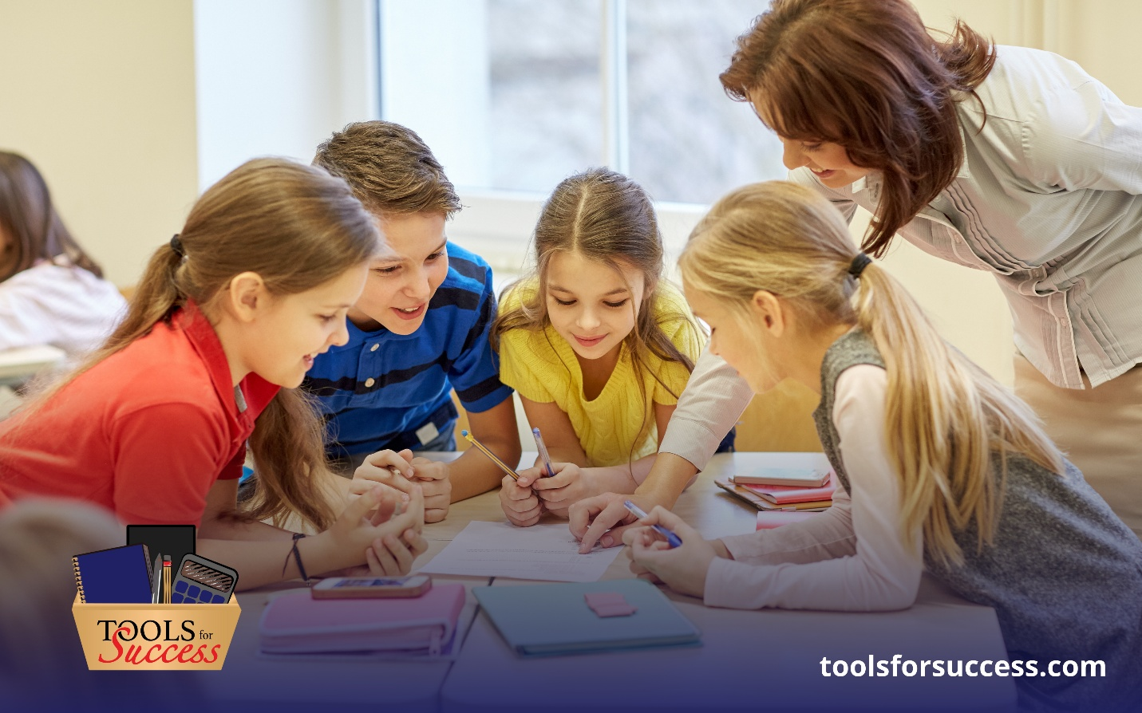

Hitting Reset: Why January Is the Perfect Time to Rebuild Classroom Routines and Relationships
After winter break, teachers and students often return with mixed energy: relief at the pause but fatigue from a long fall term. Sticky routines, uneven engagement, and fractured classroom rhythms can make the first weeks back feel like a slog.
In this timely blog from Tools for Success, we walk through why this month is just as important as the start of the school year and offer practical strategies for re-establishing routines, rebuilding relationships, and resetting your own mindset for the semester ahead.
👉 Click to read more and discover how intentional resets can make this year’s second half your most successful yet.

