It’s great to hear from you! Thank you for your interest in a partner sponsorship for the STEM Education Conference again this year. I do have you at the top of our list should a sponsorship opportunity become available for the School Leadership Conference. I should have more information on sponsorship availability for this year’s conference by mid-summer.
On a related note, I’ve sent a few emails previously and suspect they may not have reached you. The sponsorship invoice for the 2025 STEM Education Conference has not yet been paid. I’ve attached a copy of the invoice for your reference. Once that payment is processed, I will secure the partner sponsorship for the 2026 STEM Education Conference and send over the corresponding invoice.
I will also review your proposed one-hour session to see if it may be a good fit for one of the conferences.
Please feel free to reach out if you have any questions.


Why We Keep Making the Wrong People Coaches in Schools
We hear it every year: “We just don’t have the team this year.” What if the issue isn’t the team at all — but who we’ve asked to coach them? This month’s blog invites school leaders to rethink how we select and prepare instructional coaches so they can authentically support and develop the professionals they lead.
👉 Read the full blog to reflect on how coaching decisions are made in your school — and what small shifts could lead to big impact for your staff and students.
Why We Keep Making the Wrong People Coaches in Schools | Tools for Success

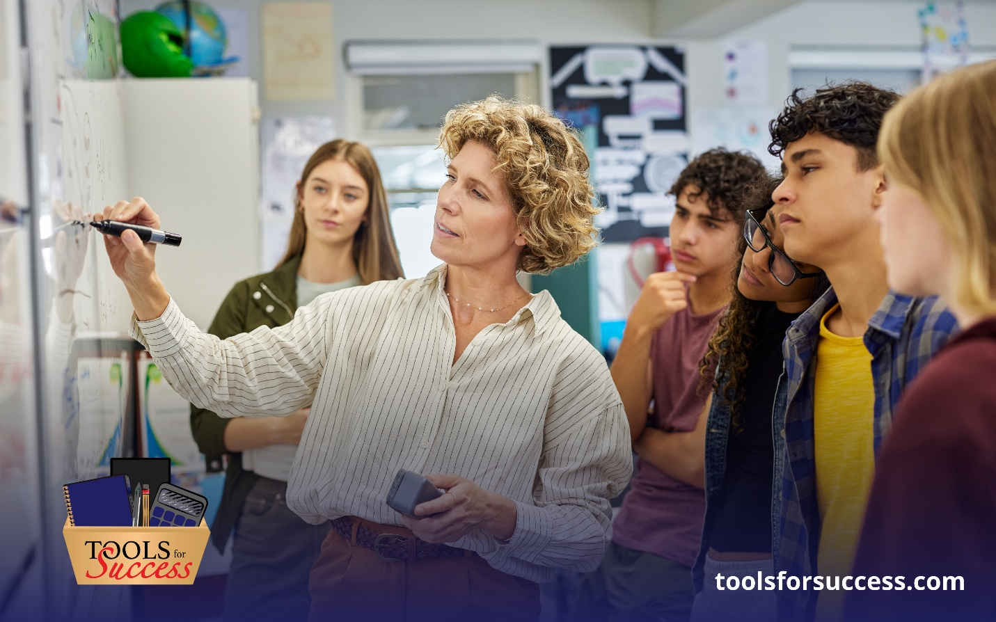

The Nonnegotiable of Great Coaching (And Why They Matter More Than Teaching Talent)
In schools, strong teaching talent doesn’t always translate into strong coaching—because the qualities that make an effective coach extend well beyond classroom expertise. This month’s blog explores the nonnegotiable traits every great coach must bring to the table and why intentional leadership choices matter more than talent alone.
👉 Read the full blog to discover what truly defines great coaching and how leaders can better support growth for educators and teams.

The Nonnegotiable of Great Coaching (And Why They Matter More Than Teaching Talent) | Tools for Success

